Dark Lane
Cheshunt
Hertfordshire
EN7 5ED
Tel: 01992 307900
Email: admin@bonnegrove.herts.sch.uk
14th January 2026

Dear Parents/Carers

Astronomy Roadshow

On Wednesday 28th January, a mobile planetarium will be visiting Bonneygrove Primary School. This exciting opportunity is open to all pupils in Nursery, Reception, Years One and Two. The children will have an immersive experience in the dome and learn fascinating facts about our solar system and beyond!

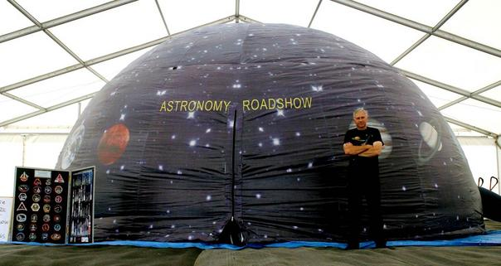

The cost of this experience is £2.55. Please log onto your child’s Arbor account under Activities/Trips to make payment. The deadline for payment is Friday 23rd January. If there are insufficient voluntary contributions this activity will not go ahead.

Yours sincerely

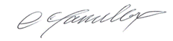
Mr Craig Hamilton
Executive Headteacher
Bonneygrove and Millbrook Primary Federation

